Year 11 Human Biology –

**Pregnancy, Birth & the Newborn** Mark: /57

Name:________________________

**Multiple choice answer grid**

**1** A B C D

**2** A B C D

**3** A B C D

**4** A B C D

**5** A B C D

**6** A B C D

**7** A B C D

**8** A B C D

**9** A B C D

**10** A B C D

**11** A B C D

**12** A B C D

**13** A B C D

**14** A B C D

**15** A B C D

**16** A B C D

**PART A: MULTIPLE CHOICE**

1. Choose the **incorrect** statement regarding the placenta.
   1. The placenta forms from a membrane that develops around the foetus.
   2. The placenta is a combination of foetal and paternal tissue.
   3. The umbilical cord attaches the placenta to the foetus.
   4. Two umbilical arteries carry blood to the placenta from the foetus.
2. What gives the placenta a large surface area?
   1. Chorionic villi.
   2. Endometrium.
   3. Umbilical arteries.
   4. Amniotic fluid.
3. Choose the **incorrect** statement. During week 4 of embryonic development;
   1. The embryo is under 4mm long.
   2. Eyes appear as slits.
   3. Tail is evident.
   4. Brain begins to form.
4. Vernix is;
   1. The substance that is discharged from the umbilical cord after birth.
   2. The placenta and umbilical cord discharged after birth.
   3. The fine hairs that cover the foetus.
   4. The waxy substance covering the baby at birth.

5. The milk let-down reflex is due to the action of which hormone?

1. prolactin
2. oxytocin
3. prostaglandins
4. oestrogen

6. Which sequence of development is the most likely for humans?

a. grasps and shakes objects; eats unaided; picks up objects between thumb and forefinger.

b. grasps and shakes objects; picks up objects between thumb and forefinger; walks.

c. eats unaided; grasps and shakes objects; picks up objects between thumb and forefinger; walks

d. eats unaided; grasps and shakes objects; picks up objects between thumb and forefinger.

7. Which statement is true?

a. Where the umbiblical cord attaches to the chorion, the placenta develops

b. The upper most layer of the embryo is the endoderm

c. The embryonic disc separates the chorion cavity and the yolk sac

d. The ectoderm will develop into the gut, trachea, lungs and liver.

8) The diagram below shows the cervix almost completely opened and the amnion is bulging in the front of the head this is:

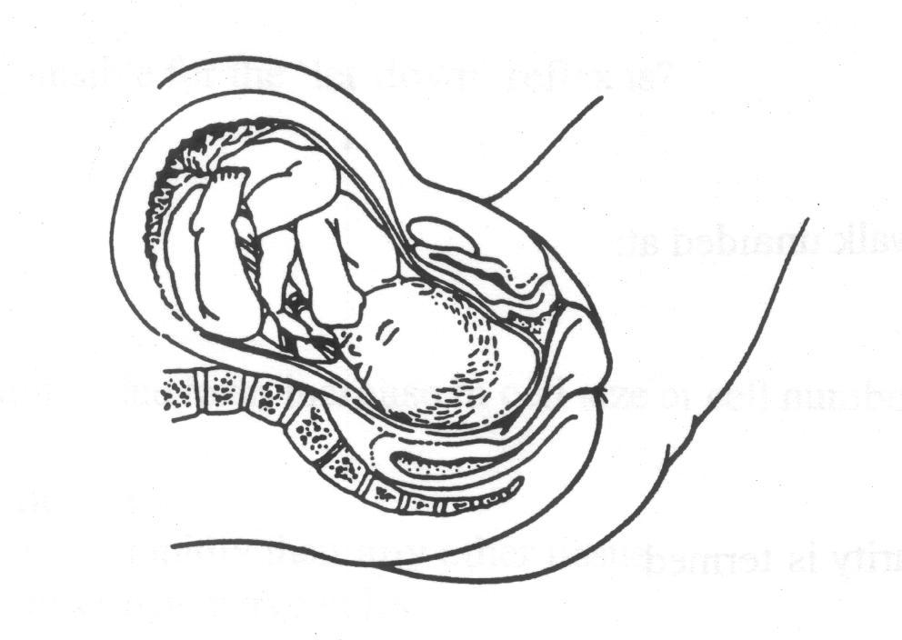

a. early in the first stage of labour

b. early in the second stage of labour

c. late in the first stage of labour

d. late in the second stage of labour

9. Which of the following substances are received by the pregnant mother from the foetus?

a. Urea and Carbon dioxide

b. Carbon dioxide and glucose

c. Urea and amino acids

d. Amino acids and glucose

10. At what stage should a baby be able to crawl to another person?

a) 1 – 3 months

b) 4 – 5 months

c) 6 – 9 months

d) 10-12 months

11. Which of the following pairs of sexually transmitted diseases are caused by viruses and are therefore difficult to treat?

1. Herpes and syphilis
2. Acquired immune deficiency syndrome and herpes
3. Syphilis and gonorrhoea
4. Acquired immune deficiency syndrome and gonorrhea

12. In treating infertile women, sometimes eggs and sperm are collected then transferred to the fallopian tubes together. This method is commonly known as:

a) ICSI

b) TET

c) ZIFT

d) GIFT

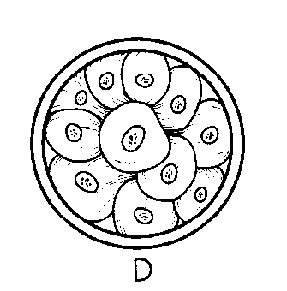13. The stage of development illustrated on the right is called:

a) morula

b) zygote

c) embryo

d) blastocyst

14. The pattern of development from head to foot is called:

a. Cephalocaudal

b. Proximodistal

c. Gross to specific

d. Socialisation

15. Which of the following about congenital disorders is **incorrect**?

a. it is present at birth

b. it is inherited from the parents

c. may be caused by a teratogen

d. may be caused by environmental factors during development within the uterus

16. Which of the following is **incorrect** about Vitamin A in the maternal diet?

a. Vitamin A can not be stored so steady intake is required

b. Demand is greatest in the final 10 weeks of pregnancy

c. Lack of vitamin A can cause spina bifida

d. Vitamin A can be found in green leafy vegetables

**PART B: SHORT ANSWER**

1)Label the following diagram of a breast (4)

2. There are well documented adverse effects on the children of smokers. State one adverse affect of the mother smoking can have on a unborn child and one on a breast fed child. (2) _______________________________________________________________________________________

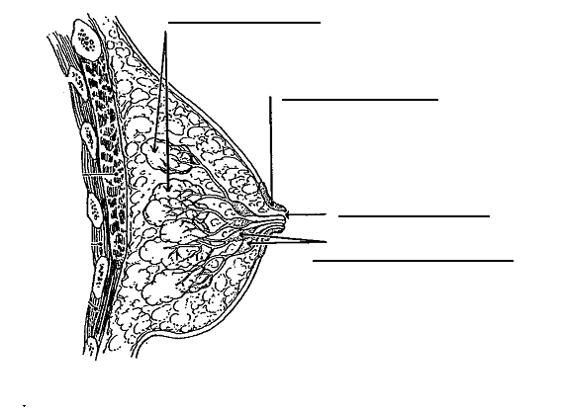

_______________________________________________________________________________________

_______________________________________________________________________________________

3. Fill in the table below regarding the changes to the mother after childbirth. (4 marks)

|  |  |
| --- | --- |
| Change | Description |
| Discharge of  fluid from uterus | ⮚ |
| Blood volume | ⮚ |
| Pulse | ⮚ |
| Menstrual cycle | ⮚ |

1. What method of diagnosis of foetal health is being shown below? (1)

What can be detected using this method? (1)

[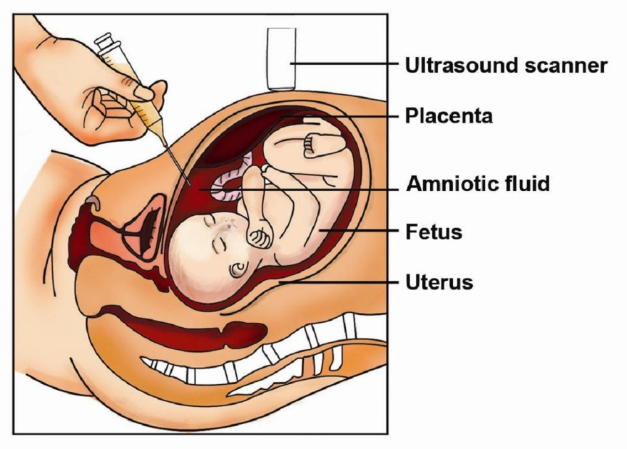](http://www.google.com.au/url?sa=i&rct=j&q=amniocentesis&source=images&cd=&cad=rja&docid=6TWEzWWG3GnVFM&tbnid=8Gy6wWi9CPIr4M:&ved=0CAUQjRw&url=http://simple-health-secrets.com/amniocentesis-images-amniocentesis-pictures/&ei=PA0kUu2NGYyglQW544Eo&psig=AFQjCNFaTeKU56kL1i5mFDHSfAdZNXNAGQ&ust=1378180782594615)

5a.  **List** TWO advantages of women using the combined pill as a method of birth control. (2)

_______________________________________________________________________________________

_______________________________________________________________________________________

_______________________________________________________________________________________

5b. **List** TWO disadvantages of women using the combined pill as a method of birth control. (2)

_______________________________________________________________________________________

_______________________________________________________________________________________

_______________________________________________________________________________________

6. In-vitro fertilisation (IVF) and gamete intrafallopian transfer (GIFT) are two types of assisted reproductive technologies.

**State** TWO differences between the two types. (2)

_______________________________________________________________________________________

_______________________________________________________________________________________

_______________________________________________________________________________________

_______________________________________________________________________________________

_______________________________________________________________________________________

_______________________________________________________________________________________

7. **Explain** how fetoscopy works.

What kind of problems can it detect? Give a specific example. (3)

_______________________________________________________________________________________

_______________________________________________________________________________________

_______________________________________________________________________________________

_______________________________________________________________________________________

_______________________________________________________________________________________

8. List two internal organ changes that occur to both males **and** females during adolescence. (2)

_______________________________________________________________________________________

_______________________________________________________________________________________

9. Which of the following is a child likely to be able to accomplish first? Explain your decision (2)

[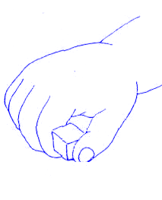](http://www.google.com.au/url?sa=i&rct=j&q=development+of+grasp+patterns+in+children&source=images&cd=&cad=rja&docid=aEdEYIcxo7YJoM&tbnid=mqGM0U7r666yNM:&ved=0CAUQjRw&url=http://connectability.ca/2011/03/21/practical-strategies-for-developing-fine-motor-skills/&ei=6A4kUvHNL8qQkwWu1IDQCQ&psig=AFQjCNEHQefTtdRd8iW0_zE0JFm7S4D9hg&ust=1378181156062010)[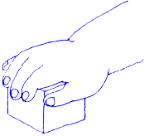](http://www.google.com.au/url?sa=i&rct=j&q=development+of+grasp+patterns+in+children&source=images&cd=&cad=rja&docid=aEdEYIcxo7YJoM&tbnid=g_yUu6QWXS_vfM:&ved=0CAUQjRw&url=http://connectability.ca/2011/03/21/practical-strategies-for-developing-fine-motor-skills/&ei=zg4kUpG_OYq3lQXr6oCABw&psig=AFQjCNEHQefTtdRd8iW0_zE0JFm7S4D9hg&ust=1378181156062010) A

B

_______________________________________________________________________________________

_______________________________________________________________________________________

_______________________________________________________________________________________

_______________________________________________________________________________________

10. The rhythm method of contraception is usually used in combination with other methods. Why is this? (1)

_______________________________________________________________________________________

_______________________________________________________________________________________

Describe two other methods of predicting ovulation which are usually used in combination with the rhythm method (4)

_______________________________________________________________________________________

_______________________________________________________________________________________

_______________________________________________________________________________________

_______________________________________________________________________________________

**PART C: EXTENDED ANSWER**

A great number of changes occur to the baby’s circulation after birth. Compare the differences of the baby’s circulation before birth and after birth. (16 marks)

__________________________________________________________________________________________

__________________________________________________________________________________________

__________________________________________________________________________________________

__________________________________________________________________________________________

__________________________________________________________________________________________

__________________________________________________________________________________________

__________________________________________________________________________________________

__________________________________________________________________________________________

__________________________________________________________________________________________

__________________________________________________________________________________________

__________________________________________________________________________________________

__________________________________________________________________________________________

__________________________________________________________________________________________

__________________________________________________________________________________________

__________________________________________________________________________________________

__________________________________________________________________________________________

__________________________________________________________________________________________

__________________________________________________________________________________________

__________________________________________________________________________________________

__________________________________________________________________________________________

__________________________________________________________________________________________

__________________________________________________________________________________________

__________________________________________________________________________________________

__________________________________________________________________________________________

__________________________________________________________________________________________

__________________________________________________________________________________________

__________________________________________________________________________________________

__________________________________________________________________________________________

__________________________________________________________________________________________

__________________________________________________________________________________________

__________________________________________________________________________________________

__________________________________________________________________________________________

__________________________________________________________________________________________

__________________________________________________________________________________________

__________________________________________________________________________________________

__________________________________________________________________________________________

__________________________________________________________________________________________

__________________________________________________________________________________________

__________________________________________________________________________________________

__________________________________________________________________________________________

__________________________________________________________________________________________

__________________________________________________________________________________________

__________________________________________________________________________________________

__________________________________________________________________________________________

__________________________________________________________________________________________

__________________________________________________________________________________________

__________________________________________________________________________________________

__________________________________________________________________________________________

__________________________________________________________________________________________

__________________________________________________________________________________________

**SOLUTIONS**

**Pregnancy, Birth & the Newborn** Mark: /60

Name:________________________

**Multiple choice answer grid**

**1** A B C D

**2** A B C D

**3** A B C D

**4** A B C D

**5** A B C D

**6** A B C D

**7** A B C D

**8** A B C D

**9** A B C D

**10** A B C D

**11** A B C D

**12** A B C D

**13** A B C D

**14** A B C D

**15** A B C D

**16** A B C D

**17** A B C D

**18** A B C D

**PART B: SHORT ANSWER**

1)Label the following diagram of a breast (4)

Opening of duct

Nipple

Lobule / Lobe

2. There are well documented adverse effects on the children of smokers. State one adverse affect of the mother smoking can have on a unborn child and one on a breast fed child. (2) Increased risk of miscarriage or lower birth weight

Milk Space



Gastrointestinal problems or respiratory problems

3. Fill in the table below regarding the changes to the mother after childbirth. (4 marks)

|  |  |
| --- | --- |
| Change | Description |
| Discharge of  fluid from uterus | ⮚mixture of blood and tissue remains |
| Blood volume | ⮚gradually reduces and returns to normal |
| Pulse | ⮚slows down |
| Menstrual cycle | ⮚begins again after a period of time |

1. What method of diagnosis of foetal health is being shown below? (1)

amniocentesis

What can be detected using this method? (1)

Biochemical effects or

Abnormalities of the chromosomes

[](http://www.google.com.au/url?sa=i&rct=j&q=amniocentesis&source=images&cd=&cad=rja&docid=6TWEzWWG3GnVFM&tbnid=8Gy6wWi9CPIr4M:&ved=0CAUQjRw&url=http://simple-health-secrets.com/amniocentesis-images-amniocentesis-pictures/&ei=PA0kUu2NGYyglQW544Eo&psig=AFQjCNFaTeKU56kL1i5mFDHSfAdZNXNAGQ&ust=1378180782594615)

5a.  **List** TWO advantages of women using the combined pill as a method of birth control. (2)



5b. **List** TWO disadvantages of women using the combined pill as a method of birth control. (2)



6. In-vitro fertilisation (IVF) and gamete intrafallopian transfer (GIFT) are two types of assisted reproductive technologies.

**State** TWO differences between the two types. (2)



7. **Explain** how fetoscopy works.

What kind of problems can it detect? Give a specific example. (3)

8. List two internal organ changes that occur to both males **and** females during adolescence. (2)



9. Which of the following is a child likely to be able to accomplish first? Explain your decision (2)

[](http://www.google.com.au/url?sa=i&rct=j&q=development+of+grasp+patterns+in+children&source=images&cd=&cad=rja&docid=aEdEYIcxo7YJoM&tbnid=mqGM0U7r666yNM:&ved=0CAUQjRw&url=http://connectability.ca/2011/03/21/practical-strategies-for-developing-fine-motor-skills/&ei=6A4kUvHNL8qQkwWu1IDQCQ&psig=AFQjCNEHQefTtdRd8iW0_zE0JFm7S4D9hg&ust=1378181156062010)[](http://www.google.com.au/url?sa=i&rct=j&q=development+of+grasp+patterns+in+children&source=images&cd=&cad=rja&docid=aEdEYIcxo7YJoM&tbnid=g_yUu6QWXS_vfM:&ved=0CAUQjRw&url=http://connectability.ca/2011/03/21/practical-strategies-for-developing-fine-motor-skills/&ei=zg4kUpG_OYq3lQXr6oCABw&psig=AFQjCNEHQefTtdRd8iW0_zE0JFm7S4D9hg&ust=1378181156062010) A

B

_______________________________________________________________________________________

_______________________________________________________________________________________

_______________________________________________________________________________________

_______________________________________________________________________________________

10. The rhythm method of contraception is usually used in combination with other methods. Why is this? (1)

_______________________________________________________________________________________

_______________________________________________________________________________________

Describe two other methods of predicting ovulation which are usually used in combination with the rhythm method (4)

_______________________________________________________________________________________

_______________________________________________________________________________________

_______________________________________________________________________________________

_______________________________________________________________________________________

**PART C: EXTENDED ANSWER**

A great number of changes occur to the baby’s circulation after birth. Compare the differences of the baby’s circulation before birth and after birth. (16 marks)



Placenta included in circulation (1) Umbilical artery and vein closed off ( 1)